**DATA ANALYTICS ASSIGNMENT 1**

Sk.Reshma

VNITSW

4thB.Tech(CSE)

21NN5A0507

**BAR CHART**

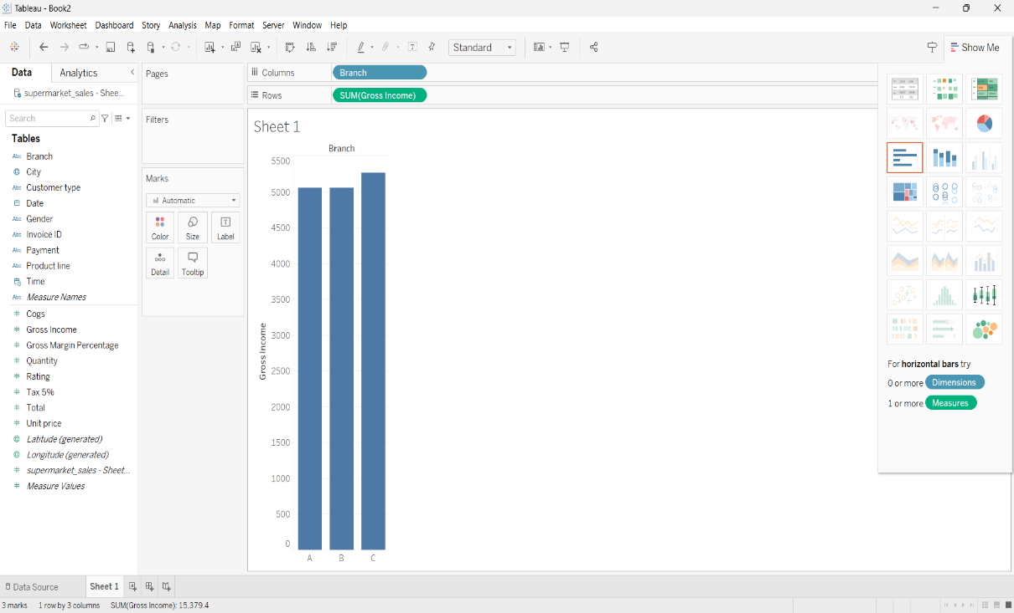

**PIE CHART**

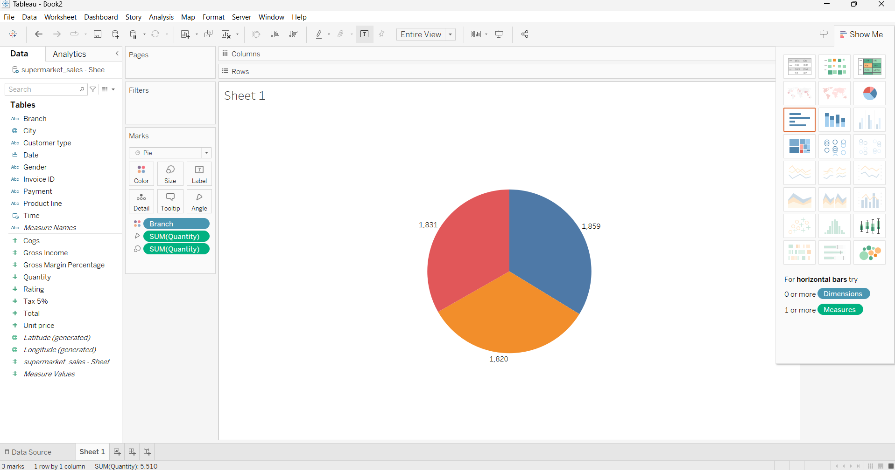

**STACKED BAR CHART**

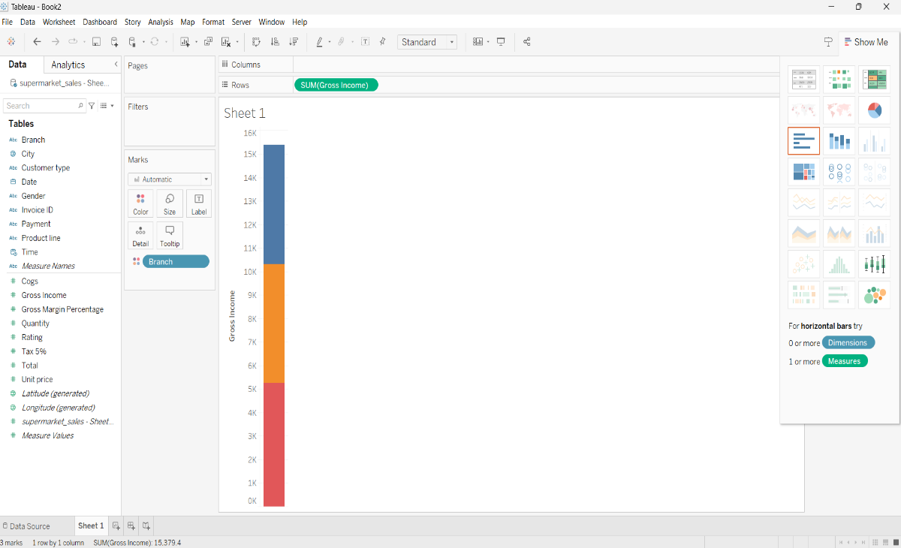

**LINE CHART**

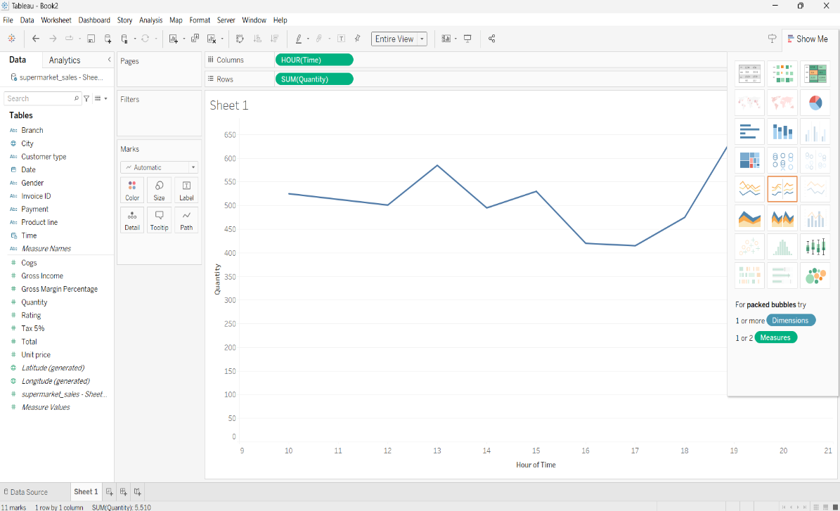

**BUBBLE CHART**

